Post Mauryan:

( 2nd bce – 3 rd BCE)

Dark age of Indian history

Political atmpohere

Regional principalities

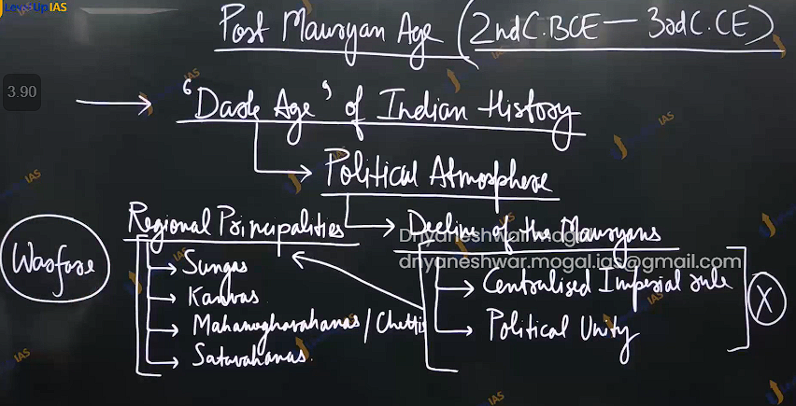

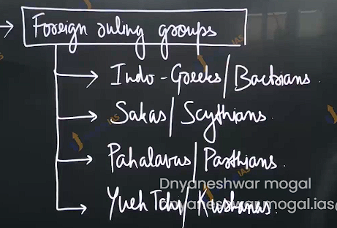

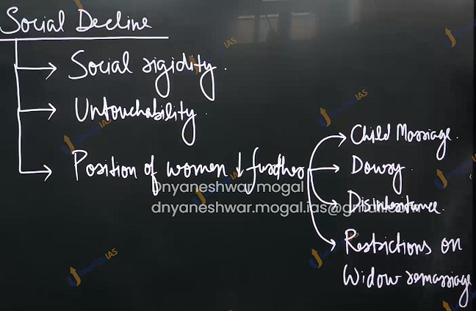

Culture stagnation :

Due to constant warfare and the entry of foreign rulers culture development , scientific enquiry educative -----dormancy, inward looking timid attitude.

Economic decline :

* 1. External trade broke down
  2. De -urbanisation and ruralisation
  3. Feudalistic tendncies

This colonial historians. There schoolership must be put in the context of wider objective.

Nationalist and Marxist historian :

Challenge dthe idea of the post Mauryan age as dark age.

Economica development :

Unparallel growth.: foreign ruling group encouraged long distance trade : indo-roman trade.

Silk route.

Midway point of global trade.

Expansion of Agriculture :

1. Irrigation facilities
2. Remarkable growth in the size of surplus
3. Cattle trade
4. State mag

Rapid growth of urbanisation

Political scenario: although political unity disappears the governance structure survived.

State formation at the regional level.

Also took place in the deep south.

Effective governance : foreign ruling groups

1. They were assimilated with the Indian identity.
2. Administrative innovation.

Greek - satrapy system.

1. Military reforms :
   1. Importance of calvary , saddle and rope stirrup

Culture :

1. gandhar , Mathura and Amaravati
2. literature beginning classical list
   1. sanskirt
   2. prakrit and pali
   3. Milind panaha.
   4. Mahabhashya ( by pantangali)
   5. Sarputrapakana.
   6. Buddhacharita.
   7. Charak shahita.
   8. Surshut shahita
   9. Education receive great degree of attention
      1. Taxila
      2. Libraries and reading house.
      3. Traditional gurukula’s.
   10. Philosophy and religion
       1. Yoga
       2. Mahayan Buddhism
       3. Indian bhakti
          1. Vaishnavism
          2. Saivism
       4. Idol worship
       5. Shrine/temple
       6. puranas
       7. avadan literature ( Buddhism’s)

society condition:

* + - 1. one hand rigidity , untouchability decline position of women Definity harmed the society.
      2. Some reformative trade. :
         1. Bhakti
         2. Political literature

Arthshatra have softer attitude towards sudhras and women.

Slave should not kill unwillingly

Society was trying to find the new balance.

Q) WHAT extent do you agree with that post Mauryan age was the dark age of Indian history.200

Q) compare and contrast the Mathura and gandhar school of art.

Q) highlight the similarities and different between bandhar Mathura and Amravati school of art

Q) examine the contribution of satvahana to Indian culture and society.

q) enumerate the essential feature of gupta administration how did gupta king project the control.

Provincial administration :

Mauryan administration.